syllabus
1. Information regarding the programme
1.1 Higher education institution | Babeş–Bolyai University
1.2 Faculty | Faculty of Political, Administrative and Communication Sciences
1.3 Department | Political Science Department - English Line of Studies
1.4 Field of study | Political Science
1.5 Study cycle | BA
1.6 Study programme / Qualification | Political Science, English language track

2. Information regarding the discipline
2.1 Name of the discipline (en) (ro) |  |  | Governance studies/ Studii de guvernanta si guvernare
2.2 Course coordinator |  |  | Anca Sinea, PhD. Lect.
2.3 Seminar coordinator |  |  | Anca Sinea, PhD. Lect.
2.4. Year of study | 3 | 2.5 Semester | 2 | 2.6. Type of evaluation | E | 2.7 Type of discipline | DS
2.8 Code of the discipline |  | ULE1632

3. Total estimated time (hours/semester of didactic activities)
3.1 Hours per week | 3 | Of which: 3.2 course |  | 2 | 3.3 seminar/laboratory | 1
3.4 Total hours in the curriculum | 36 | Of which: 3.5 course |  | 24 | 3.6 seminar/laboratory | 12
Time allotment: 3hrs. face to face, 7hrs. individual learning |  |  |  |  |  | hours
Learning using manual, course support, bibliography, course notes |  |  |  |  |  | 3x12
Additional documentation (in libraries, on electronic platforms, field documentation) |  |  |  |  |  | 1x12
Preparation for seminars/labs, homework, papers, portfolios and essays |  |  |  |  |  | 3x12
Tutorship
Evaluations
Other activities: ..................
3.7 Total individual study hours |  | 84
3.8 Total hours per semester |  | 120
3.9 Number of ECTS credits |  | 5

4. Prerequisites (if necessary)
4.1. curriculum
4.2. competencies

5. Conditions (if necessary)
5.1. for the course | - Academic dishonesty - plagiarism, cheating, fabrication or multiple submission - will not be tolerated. Punishment will be in accordance with the department’s rules. For details, see https://www.fspac.ubbcluj.ro/application/files/9215/7017/6735/FSPAC-code-of-ethics.pdf
5.2. for the seminar /lab activities | - Participation to 75% percent of the seminars (10 meetings) is mandatory, according to Art. 29 (2) of the “Statute of the BBU Student”. In the case of lack of attendance to 75% percent of the seminars, the right to participate in the exam is lost.

6. Specific competencies acquired
Professional competencies | - Applying the basics of social and political theories in understanding, analyzing and evaluating social-political organization of societies in the EU  - Analysis of a particular situation by applying certain principles, theories and fundamental methods of social sciences in the EU  - The realization, individually or in a team, of a project related to European integration  - Appropriate use of political science concepts applicable to the EU  - Utilizing the conceptual apparatus of political science in evaluating the relevance and impact of socio-political theories in the EU  - Utilizing fundamental concepts of political science in describing and explaining the emergence and unfolding of certain events and processes in the EU  - Utilizing methods of analyzing socio-political processes in the EU  - Elaborating analyses on the state and development of the EU  - Identifying the elements of political analysis methodology relevant to the EU  - Defining and utilizing certain theories and methods in explaining particular disputes and conflicts of social and political nature in the EU  - Utilizing the methodology of political sciences in analyzing certain processes of contemporary socio-political systems in the EU  - Utilizing technics of political analysis in critical evaluation of particular situations in which socio-political systems find themselves in the EU
Transversal competencies | - Understanding and explaining policy processes  - utilizing policy evaluation techniques and recommendations

7. Objectives of the discipline (outcome of the acquired competencies)
7.1 General objective of the discipline | - The aim of the course is to provide students with the basic conceptual and analytical tools required by the systematic understanding of the functioning of the EU. The course will cover topics such as the ideas based on which the EU was created, the historic evolutions, theories of EU integration, governance in the EU, politics and policies of the EU. Seminars will be centered around EU policies and will involve individual academic research and reporting based on topics of choice.
7.2 Specific objective of the discipline | - By participating in the courses and seminars the students will gain an understanding of the fundamental concepts, methods and interpretative frameworks needed in the more systematic understanding of the EU. Students will also gain understanding how principles of democratic governance apply at a broader than state level, while applying critical thinking when dealing with complex social and political issues that involve this level of decision-making.  - Key Concepts: European Union, European construction, deepening and widening, European integration, interdependence, subsidiarity, suis generis, acquis communautaire, European institutions, European treaties, theories of EU integration, intergovernmentalism, supranationalism, federalism, multilevel governance, decision-making, EU legislation, interests

8. Content
8.1 Course | Teaching methods | Remarks
1. Introductory course  Discussion on the syllabus structure and course and seminar requirements | Interactive presentation | Students are expected to require the clarification of all questions regarding the course and seminar structure and requirements
2. Fundamental questions on the European Union  During this interactive course most important questions related to the existence, sustainability and future models of the EU will be discussed  Recommended reading:  Nugent, N. The Government and Politics of the European Union, Bloomsbury Publishing, 2017, Ch.1 | Interactive presentation
3. The history of European integration  The most important moments of EU integration will be discussed from a historical perspective.  Recommended reading:  Nugent, N. The Government and Politics of the European Union, Bloomsbury Publishing, 2017, Ch. 2-5  Chalmers, D. at al., European Union Law, Second edition, Cambdige University Press, 2010, Ch. 1-3 | Interactive presentation
4. Ideas in EU integration  The idea of European integration is not new and is complex. The fundamental thinking, on which the idea of a European union is based, but also ideas that are contrary to the European ideal will be explored during this course. The most important values for which the EU stands and their operationalization in various policies will also be discussed.  Recommended reading:  Nugent, N. The Government and Politics of the European Union, Bloomsbury Publishing, 2017, Ch. 24-25  Biscop, S. et al (eds). The EU and the European Security Strategy. Forging a Global Europe, Routledge, 2008, Ch. 14, 24 | Interactive presentation
5. EU international leadership. neighbourhood policy, enlargement  In a multipolar international community, the European Union represents a set of values and interests. The EU’s perspective on its near and more distant neighbourhood will be discussed, as well as its most important partnerships, including the transatlantic strategy and the European enlargement policy.  Recommended reading:  Nugent, N. The Government and Politics of the European Union, Bloomsbury Publishing, 2017, Ch. 22  Biscop, S. et al (eds). The EU and the European Security Strategy. Forging a Global Europe, Routledge, 2008, Ch. 9, 15, 18, 30, 36, 37  Cameron, F. An introduction to European Foreign Policy, Routledge 2007, Ch. 1, 6, 7, 13  Chalmers, D. at al., European Union Law, Second edition, Cambdige University Press, 2010, Ch.15  El-Agraa, A. M. (2011). The European Union: Economics and policies (9th ed.). Cambridge University Press. Part VI, VII  Kaiser, W., & Elvert, J. (Eds.). (2004). European Union enlargement: A comparative history. | Interactive presentation
6. The EU constitutional framework  The treaties that make the underlying legal structure of the EU will be discussed and ideas around the constitutional future of the European Union.  Recommended reading:  Nugent, N. The Government and Politics of the European Union, Bloomsbury Publishing, 2017, Ch. 3-8  Chalmers, D. at al., European Union Law, Second edition, Cambdige University Press, 2010, Ch. 3-9 | Interactive presentation
7. European Institutions 1: The European Parliament and Questions Related to European Democracy  The nature and functions of the European Parliament from a historical perspective. Democracy and representation in the EU.  Required readings:  Nugent, N. The Government and Politics of the European Union, Bloomsbury Publishing, 2017, Ch.12  Chalmers, D. at al., European Union Law, Second edition, Cambdige University Press, 2010, Ch. 2.5 | Interactive presentation
8. European Institutions 2: The European Council  Required readings:  Nugent, N. The Government and Politics of the European Union, Bloomsbury Publishing, 2017, 11  Chalmers, D. at al., European Union Law, Second edition, Cambdige University Press, 2010, Ch. 2.3, 2.4 | Interactive presentation
9. European Institutions 3: The Council of the European Union  Required readings:  Nugent, N. The Government and Politics of the European Union, Bloomsbury Publishing, 2017, Ch.10 | Interactive presentation
10. European Institutions 4: The European Commission  Required readings:  Nugent, N. The Government and Politics of the European Union, Bloomsbury Publishing, 2017, Ch.9  Chalmers, D. at al., European Union Law, Second edition, Cambdige University Press, 2010, Ch. 2.2 | Interactive presentation
11. Other European Institutions and the European Decision-Making Process  Required readings:  Nugent, N. The Government and Politics of the European Union, Bloomsbury Publishing, 2017, Part IV  Chalmers, D. at al., European Union Law, Second edition, Cambdige University Press, 2010, Ch. 3, 9. | Interactive presentation
Bibliography

Biscop, S. et al (eds). The EU and the European Security Strategy. Forging a Global Europe, Routledge, 2008
Cameron, F. An introduction to European Foreign Policy, Routledge 2007
Chalmers, D. at al., European Union Law, Second edition, Cambdige University Press, 2010
Nugent, N. The Government and Politics of the European Union, Bloomsbury Publishing, 2017

8.2 Seminar / laboratory | Teaching methods | Remarks
Topic I. Question on the EU Economic model
Seminar 1: A New and European Economic model: Green and circular economy

Aydin, T., Galetto, C., Jona Falco, J., Minasian, A., Renner, L., & Segrè, E. (31 martie 2025). The Geopolitics of the European Green Deal: From Fragile to Strategic Dependencies? European Chair for Sustainable Development and Climate Transition, Sciences Po. https://www.sciencespo.fr/chair-sustainable-development/news/the-geopolitics-of-the-european-green-deal-from-fragile-to-strategic-dependencies/
Pahle, M., Sultani, D., & Zachmann, G. (24 februarie 2026). Defragmenting European Union climate policy. Bruegel. https://www.bruegel.org/policy-brief/defragmenting-european-union-climate-policy
Seminar 2: Digital EU

Burwell, F., & Propp, K. (14 ianuarie 2026). Digital sovereignty: Europe’s declaration of independence? Atlantic Council. https://www.atlanticcouncil.org/in-depth-research-reports/report/digital-sovereignty-europes-declaration-of-independence/

Topic II. European Leadership
Seminar 3: European commercial spheres of influence

Korteweg, R., & van Wijk, D. (octombrie 2025). Raising the Standard: How to unlock the geopolitical potential of Europe’s internal market (Clingendael Report). Netherlands Institute of International Relations - Clingendael. https://www.clingendael.org/sites/default/files/2025-10/Report_Raising_the_Standard.pdf
Seminar 4: UE e military power?

Nizhnikau, R., Karjalainen, T., & Jokela, J. P. (1 septembrie 2025). InvigoratEU Policy Paper on Demands for European security and defence cooperation in Ukraine after Russia’s invasion (D8.3). Finnish Institute of International Affairs. https://fiia.fi/en/publication/demands-for-european-security-and-defence-cooperation-in-ukraine-after-russias-invasion

Wallander, C. A. (24 iunie 2025). Beware the Europe You Wish For: The Downsides and Dangers of Allied Independence. Foreign Affairs. https://www.foreignaffairs.com/europe/beware-europe-you-wish-wallander
Seminar 5: Global European Leadership in a multi-crisis environment

Mustasilta, K., Karjalainen, T., & Tammikko, T. (2025). The European Union’s crisis management efforts: Evolution amid a shifting international order and the war in Ukraine (FIIA Briefing Paper No. 427). Finnish Institute of International Affairs. https://fiia.fi/en/publication/the-european-unions-crisis-management-efforts

Seminar 6: UE widening and transforming

Emerson, M., & Blockmans, S. (2025, September 18). How to radically simplify and streamline the EU enlargement process. Centre for European Policy Studies. https://www.ceps.eu/ceps-publications/how-to-radically-simplify-and-streamline-the-eu-enlargement-process/

Shopov, V. (2025, December 23). The next “big bang”: How the EU can fast-track enlargement amid geopolitical tensions. European Council on Foreign Relations. https://ecfr.eu/article/the-next-big-bang-how-the-eu-can-fast-track-enlargement-amid-geopolitical-tensions/

Morina, E. (2025, December 18). Accelerate the accessions: Why faster is better in EU enlargement policy. European Council on Foreign Relations. https://ecfr.eu/publication/accelerate-the-accessions-why-faster-is-better-in-eu-enlargement-policy/

Seminar 7: Migration in the UE

Pascouau, Y. (2021, August 24). L’Europe et l’asile: D’un espace de protection à un espace protégé. Institut Jacques Delors. https://institutdelors.eu/en/publication/leurope-et-lasile-dun-espace-de-protection-a-un-espace-protege-2/
Seminar 8: Inequalities in the UE

Zucman, G. (2026, January 2). Decline, what decline? The myth of dying Europe. East Anglia Bylines. https://eastangliabylines.co.uk/business/economics/decline-what-decline-the-myth-of-dying-europe/

Seminar 9: A democracy shield for the UE?

Dolan, C. (2025, November 12). Democracy shield: Defense or distraction? European Policy Centre. https://www.epc.eu/publication/democracy-shield-defense-or-distraction/
Bentzen, N. (2026, January 15). The European Democracy Shield: An overview. European Parliamentary Research Service (EPRS), European Parliament Think Tank. https://epthinktank.eu/2026/01/15/the-european-democracy-shield-an-overview/
Seminar 10: A more trusted UE

Kizilova, K. (2024, March 11). Trust in the European Union and turnout in European Parliament elections (TRUEDEM project presentation). TRUEDEM: Trust in European Democracies Project. https://www.truedemdata.eu/truedem/TRUEDEM_Kizilova_11_03_2024.pdf
Seminar 11: Reforming the UE

Grant, C., & Letta, E. (2025, March 11). Thinking European first and its implications. Bruegel. https://www.bruegel.org/analysis/thinking-european-first-and-its-implications
Seminar 12: Budgeting for a reformed UE

https://www.youtube.com/watch?v=9gEvFEUYb0s&themeRefresh=1

9. Corroborating the content of the discipline with the expectations of the epistemic community, professional associations and representative employers within the field of the program

- The course will provide the students with the basic conceptual and analytical tools required by the systematic understanding of the history, nature and functions of the European Union.

10. Evaluation
Type of activity | 10.1 Evaluation criteria | 10.2 Evaluation methods | 10.3 Share in the grade (%)
10.4 Course | Exam | Oral examination based on two randomly assigned question | 60%
10.5 Seminar/lab activities | Active, knowledgeable participation | Weekly test based on texts  Active participation based on readings | 40%
10.6 Minimum performance standards
Eligibility criteria for the oral exam:
- Participation in 75% of the seminars;

- Students who lose their right to participate in the regular examination session due to lack of seminar attendance or poor seminar activity won’t be received in the re-examination session either. They will have to enroll to the class in the next academic year.

Data | Semnătura titularului de curs | Semnătura titularului de seminar
25.09. 2024 | 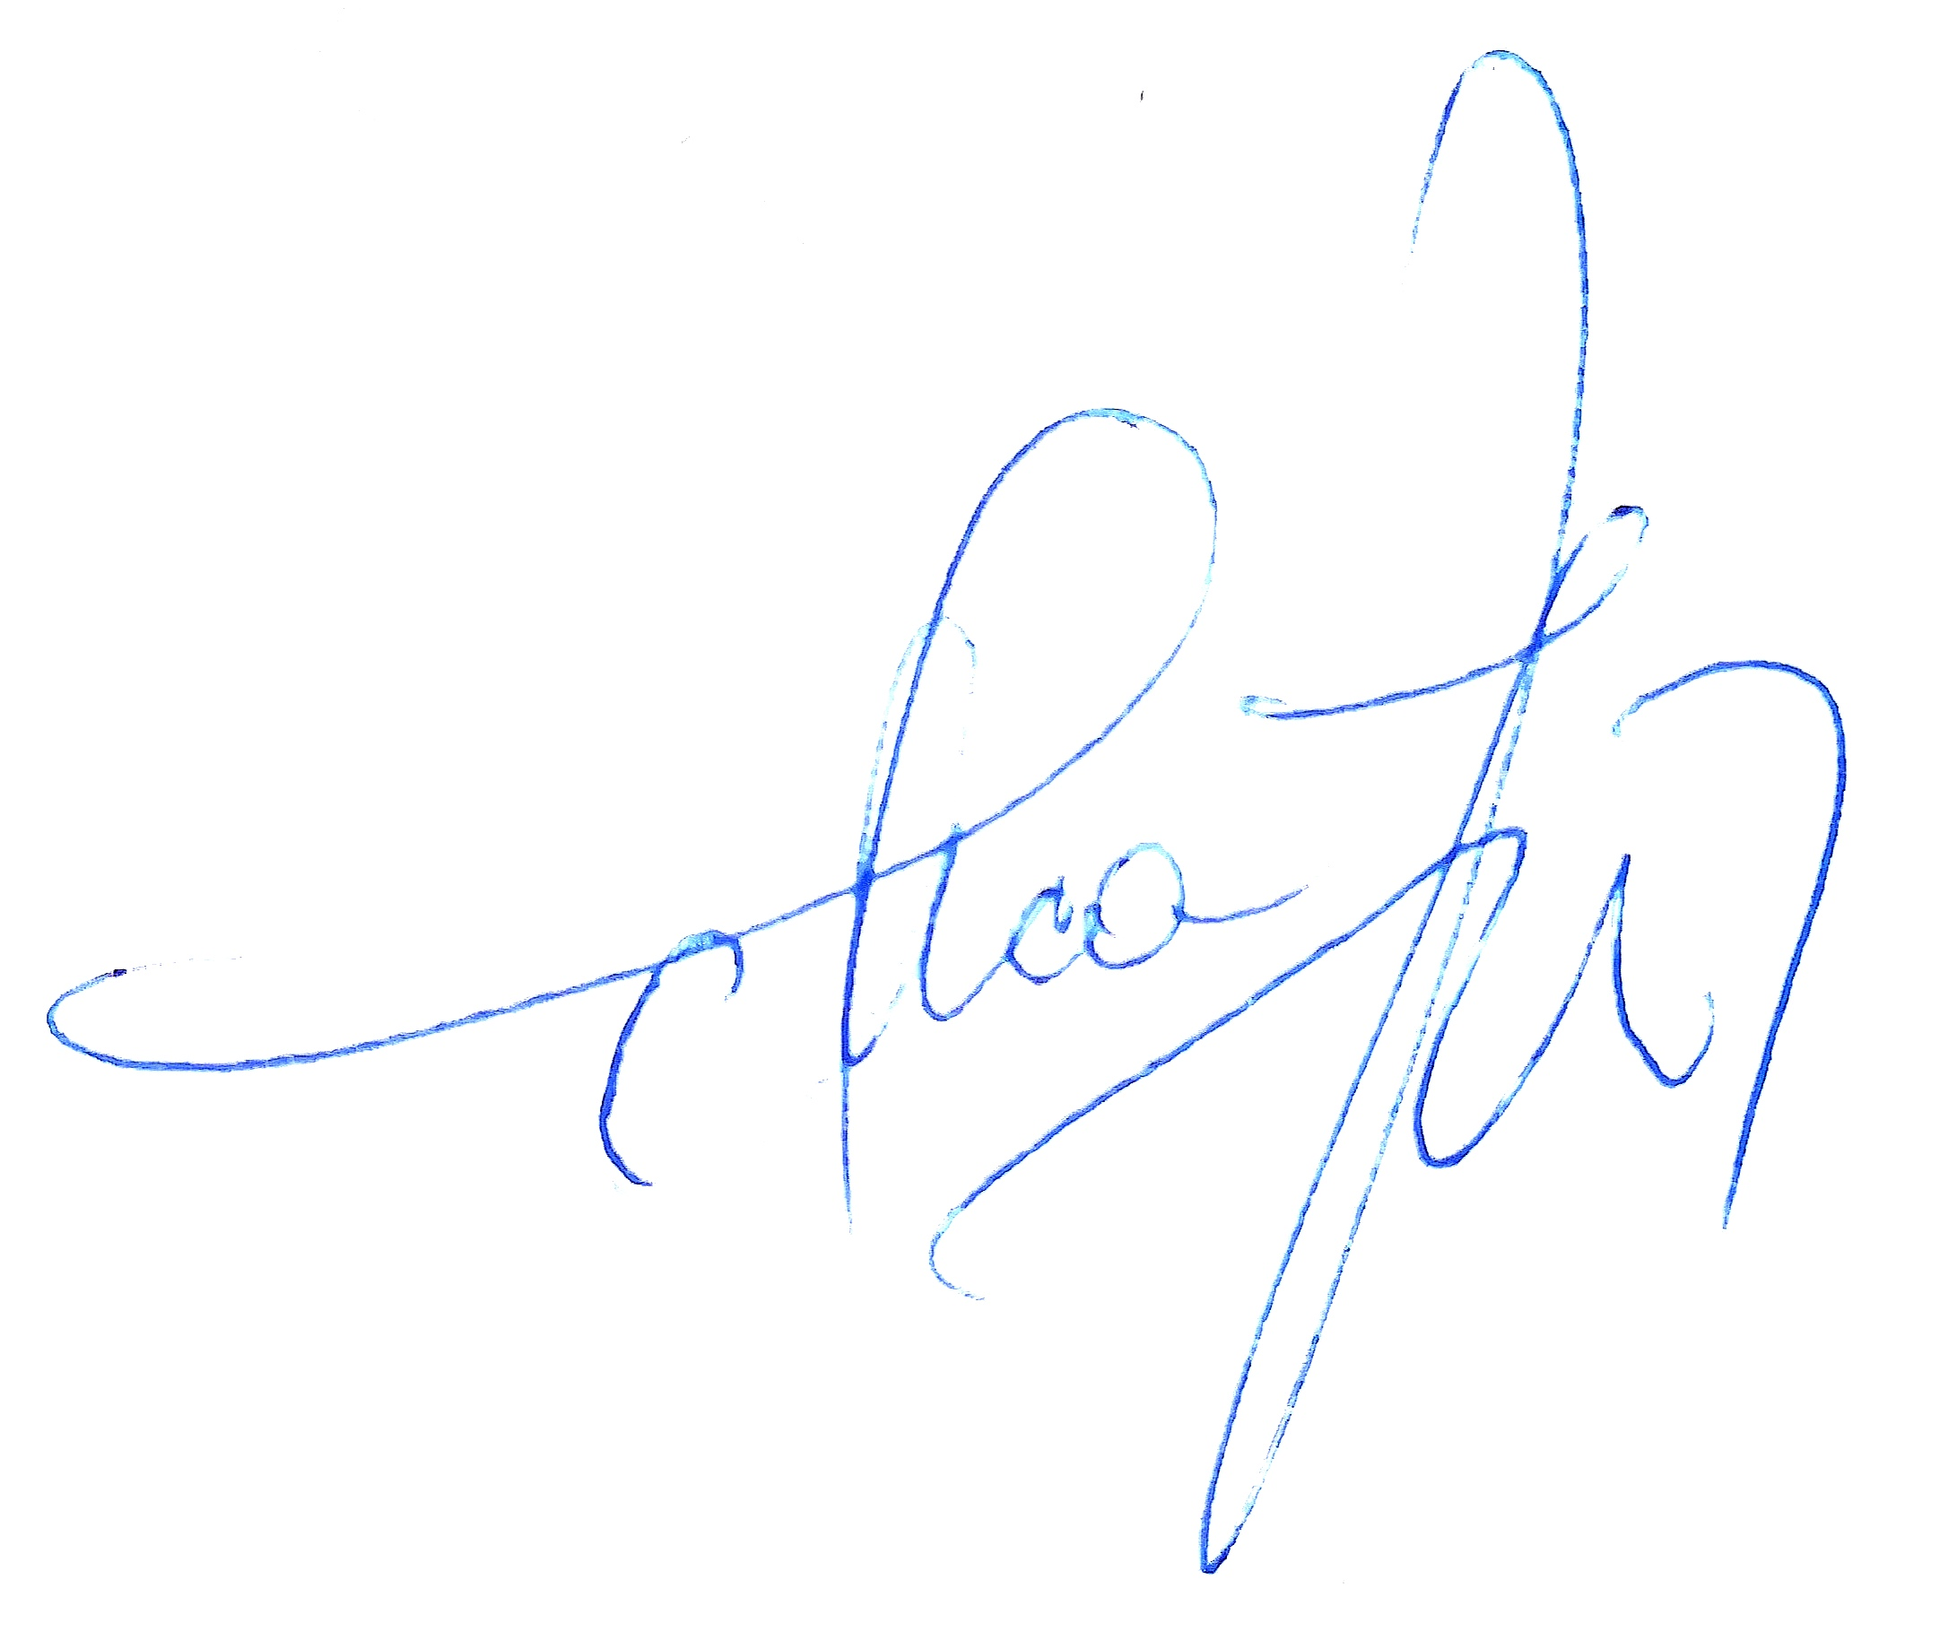
Data avizării în departament |  | Semnătura directului de departament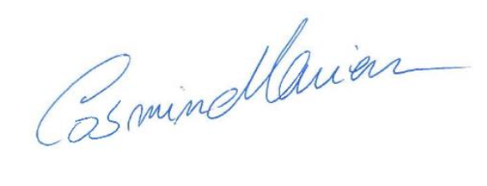
25.09. 2024

