syllabus
1. Information regarding the programme
1.1 Higher education institution | Babeş–Bolyai University
1.2 Faculty | Faculty of Political, Administrative and Communication Sciences
1.3 Department | Political Science Department - English Line of Studies
1.4 Field of study | Political Science
1.5 Study cycle | BA
1.6 Study programme / Qualification | Political Science, English language track

2. Information regarding the discipline
2.1 Name of the discipline (en) (ro) |  |  | Governance studies/ Studii de guvernanta si guvernare
2.2 Course coordinator |  |  | Anca Sinea, PhD. Lect.
2.3 Seminar coordinator |  |  | Anca Sinea, PhD. Lect.
2.4. Year of study | 3 | 2.5 Semester | 2 | 2.6. Type of evaluation | E | 2.7 Type of discipline | DS
2.8 Code of the discipline |  | ULE1632

3. Total estimated time (hours/semester of didactic activities)
3.1 Hours per week | 3 | Of which: 3.2 course |  | 2 | 3.3 seminar/laboratory | 1
3.4 Total hours in the curriculum | 10x14 | Of which: 3.5 course |  | 24 | 3.6 seminar/laboratory | 12
Time allotment: 3hrs. face to face, 7hrs. individual learning |  |  |  |  |  | hours
Learning using manual, course support, bibliography, course notes |  |  |  |  |  | 3x12
Additional documentation (in libraries, on electronic platforms, field documentation) |  |  |  |  |  | 1x12
Preparation for seminars/labs, homework, papers, portfolios and essays |  |  |  |  |  | 3x12
Tutorship
Evaluations |  |  |  |  |  | 2
Other activities: ..................
3.7 Total individual study hours |  | 84
3.8 Total hours per semester |  | 10x14
3.9 Number of ECTS credits |  | 5

4. Prerequisites (if necessary)
4.1. curriculum
4.2. competencies

5. Conditions (if necessary)
5.1. for the course | - Academic dishonesty - plagiarism, cheating, fabrication or multiple submission - will not be tolerated. Punishment will be in accordance with the department’s rules. For details, see https://www.fspac.ubbcluj.ro/application/files/9215/7017/6735/FSPAC-code-of-ethics.pdf
5.2. for the seminar /lab activities | - Participation to 75% percent of the seminars (10 meetings) is mandatory, according to Art. 29 (2) of the “Statute of the BBU Student”. In the case of lack of attendance to 75% percent of the seminars, the right to participate in the exam is lost.

6. Specific competencies acquired
Professional competencies | - Applying the basics of social and political theories in understanding, analyzing and evaluating social-political organization of societies in the EU  - Analysis of a particular situation by applying certain principles, theories and fundamental methods of social sciences in the EU  - The realization, individually or in a team, of a project related to European integration  - Appropriate use of political science concepts applicable to the EU  - Utilizing the conceptual apparatus of political science in evaluating the relevance and impact of socio-political theories in the EU  - Utilizing fundamental concepts of political science in describing and explaining the emergence and unfolding of certain events and processes in the EU  - Utilizing methods of analyzing socio-political processes in the EU  - Elaborating analyses on the state and development of the EU  - Identifying the elements of political analysis methodology relevant to the EU  - Defining and utilizing certain theories and methods in explaining particular disputes and conflicts of social and political nature in the EU  - Utilizing the methodology of political sciences in analyzing certain processes of contemporary socio-political systems in the EU  - Utilizing technics of political analysis in critical evaluation of particular situations in which socio-political systems find themselves in the EU
Transversal competencies | - Understanding and explaining policy processes  - utilizing policy evaluation techniques and recommendations

7. Objectives of the discipline (outcome of the acquired competencies)
7.1 General objective of the discipline | - The aim of the course is to provide students with the basic conceptual and analytical tools required by the systematic understanding of the functioning of the EU. The course will cover topics such as the ideas based on which the EU was created, the historic evolutions, theories of EU integration, governance in the EU, politics and policies of the EU. Seminars will be centered around EU policies and will involve individual academic research and reporting based on topics of choice.
7.2 Specific objective of the discipline | - By participating in the courses and seminars the students will gain an understanding of the fundamental concepts, methods and interpretative frameworks needed in the more systematic understanding of the EU. Students will also gain understanding how principles of democratic governance apply at a broader than state level, while applying critical thinking when dealing with complex social and political issues that involve this level of decision-making.  - Key Concepts: European Union, European construction, deepening and widening, European integration, interdependence, subsidiarity, suis generis, acquis communautaire, European institutions, European treaties, theories of EU integration, intergovernmentalism, supranationalism, federalism, multilevel governance, decision-making, EU legislation, interests

8. Content
8.1 Course | Teaching methods | Remarks
1. Introductory course  Discussion on the syllabus structure and course and seminar requirements | Interactive presentation | Students are expected to require the clarification of all questions regarding the course and seminar structure and requirements
2. Fundamental questions on the European Union  During this interactive course most important questions related to the existence, sustainability and future models of the EU will be discussed  Recommended reading:  Nugent, N. The Government and Politics of the European Union, Bloomsbury Publishing, 2017, Ch.1 | Interactive presentation
3. The history of European integration  The most important moments of EU integration will be discussed from a historical perspective.  Recommended reading:  Nugent, N. The Government and Politics of the European Union, Bloomsbury Publishing, 2017, Ch. 2-5  Chalmers, D. at al., European Union Law, Second edition, Cambdige University Press, 2010, Ch. 1-3 | Interactive presentation
4. Ideas in EU integration  The idea of European integration is not new and is complex. The fundamental thinking, on which the idea of a European union is based, but also ideas that are contrary to the European ideal will be explored during this course. The most important values for which the EU stands and their operationalization in various policies will also be discussed.  Recommended reading:  Nugent, N. The Government and Politics of the European Union, Bloomsbury Publishing, 2017, Ch. 24-25  Biscop, S. et al (eds). The EU and the European Security Strategy. Forging a Global Europe, Routledge, 2008, Ch. 14, 24 | Interactive presentation
5. EU integration: Past, present and future  The idea of the EU as a suis generis concept will be discussed. The most notable changes in the European construction have evolved around moments of enlargement. The evolution of the concept, the conditions for enlargement and the future commitment to enlargement will be discussed during this course.  Recommended reading:  Nugent, N. The Government and Politics of the European Union, Bloomsbury Publishing, 2017, Ch. 26  Biscop, S. et al (eds). The EU and the European Security Strategy. Forging a Global Europe, Routledge, 2008, Ch. 9, 15 | Interactive presentation
6. Imagining the world from the European Union  In a multipolar international community, the European Union stands for a set of values and interests. The UE perspective on near and far neighborhood, most important partnerships, including the transatlantic strategy will be discussed; the EU strategy on public diplomacy will also be considered.  Recommended reading:  Nugent, N. The Government and Politics of the European Union, Bloomsbury Publishing, 2017, Ch. 22  Biscop, S. et al (eds). The EU and the European Security Strategy. Forging a Global Europe, Routledge, 2008, Ch. 9, 15, 18, 30, 36, 37  Cameron, F. An introduction to European Foreign Policy, Routledge 2007, Ch. 1, 6, 7, 13  Chalmers, D. at al., European Union Law, Second edition, Cambdige University Press, 2010, Ch.15 | Interactive presentation
7. The EU constitutional framework  The treaties that make the underlying legal structure of the EU will be discussed and ideas around the constitutional future of the European Union.  Recommended reading:  Nugent, N. The Government and Politics of the European Union, Bloomsbury Publishing, 2017, Ch. 3-8  Chalmers, D. at al., European Union Law, Second edition, Cambdige University Press, 2010, Ch. 3-9 | Interactive presentation
8. European Institutions 1: European Parliament  The nature and functions of the European Parliament in a historical perspective. Democracy and representation in the EU  Required readings:  Nugent, N. The Government and Politics of the European Union, Bloomsbury Publishing, 2017, Ch.12  Chalmers, D. at al., European Union Law, Second edition, Cambdige University Press, 2010, Ch. 2.5 | Interactive presentation
9. European Institutions 2: European Council and the Council of the European Union  The nature and functions of the European Council and the Council of the European Union. The role of the Member States in the EU.  Required readings:  Nugent, N. The Government and Politics of the European Union, Bloomsbury Publishing, 2017, Ch.10,11  Chalmers, D. at al., European Union Law, Second edition, Cambdige University Press, 2010, Ch. 2.3, 2.4 | Interactive presentation
10. European Institutions 3: The European Commission  The nature and functions of the European Union. The limits and opportunities for executive leadership in the EU.  Required readings:  Nugent, N. The Government and Politics of the European Union, Bloomsbury Publishing, 2017, Ch.9  Chalmers, D. at al., European Union Law, Second edition, Cambdige University Press, 2010, Ch. 2.2 | Interactive presentation
11. European politics and questions on European Democracy: Democratic backsliding and citizen disengagement  Voter engagement, legitimacy and freedoms in the EU; democratic backsliding.  Required readings:  Biscop, S. et al (eds). The EU and the European Security Strategy. Forging a Global Europe, Routledge, 2008, Ch. 39 | Interactive presentation
12. European Policies and the process of complex decision-making  Policy actors and processes; Market policies; Functional Policies; Sectoral Policies; Macro-economic and Financial policies; Foreign Affairs Policies; The Budget  Required readings:  Nugent, N. The Government and Politics of the European Union, Bloomsbury Publishing, 2017, Part IV  Chalmers, D. at al., European Union Law, Second edition, Cambdige University Press, 2010, Ch. 3, 9. | Interactive presentation
Bibliography

8.2 Seminar / laboratory | Teaching methods | Remarks
Seminar 1: Introduction
Seminar 2: The European Green deal. Fundamental principles, interests and implications

Wolf, S., Teitge, J., Mielke, J. et al. The European Green Deal — More Than Climate Neutrality. Intereconomics 56, 99–107 (2021). https://doi.org/10.1007/s10272-021-0963-z
Sikora, A. European Green Deal – legal and financial challenges of the climate change. ERA Forum 21, 681–697 (2021). https://doi.org/10.1007/s12027-020-00637-3
Seminar 3: The Digital Age
Decision (EU) 2022/2481 of the European Parliament and of the Council of 14 December 2022 establishing the Digital Decade Policy Programme 2030 (Text with EEA relevance)

https://www.thelancet.com/journals/landig/article/PIIS2589-7500(20)30112-6/fulltext?disciplines=9&elqTrackId=f6cb646fa95d49b0a836e01ef5d6f2f1&elq=~~eloqua..type--emailfield..syntax--recipientid..encodeFor--url~~&elqaid=~~eloqua..type--emailfield..syntax--elqassetid..encodeFor--url~~&elqat=~~eloqua..type--emailfield..syntax--elqassettype..encodeFor--url~~&elqCampaignId=~~eloqua..type--campaign..campaignid--0..fieldname--id..encodeFor--url~~&elqcst=272&elqcsid=~~elqGlobalSectionIdToken~~&/p_p_style
Seminar 4: European External Action
Esther Barbé & Pol Morillas (2019) The EU global strategy: the dynamics of a more politicized and politically integrated foreign policy¹, Cambridge Review of International Affairs, 32:6, 753-770, DOI: 10.1080/09557571.2019.1588227
Seminar 5: Press club
Recommended platforms:
- https://www.politico.eu
- https://commission.europa.eu/index_en
- https://ecfr.eu
- https://www.europarl.europa.eu/news/en
- https://epthinktank.eu
- https://www.ceps.eu
- https://epc.eu/en/
- https://cerre.eu
- https://www.chathamhouse.org/regions/europe
- https://www.bruegel.org
- https://carnegieeurope.eu
- https://institutdelors.eu/en/

Seminar 6: Press club
Seminar 7: Press club
Seminar 8: Press club
Seminar 9: Press club
Seminar 10: Press club
Seminar 11: Press club
Seminar 12: Press club
Bibliography

9. Corroborating the content of the discipline with the expectations of the epistemic community, professional associations and representative employers within the field of the program

- The course will provide the students with the basic conceptual and analytical tools required by the systematic understanding of the history, nature and functions of the European Union.

10. Evaluation
Type of activity | 10.1 Evaluation criteria | 10.2 Evaluation methods | 10.3 Share in the grade (%)
10.4 Course | Exam | Oral examination based on two randomly assigned question | 60%
10.5 Seminar/lab activities | Active, knowledgeable participation | Active participation based on readings and seminar tasks will be graded with 1 point for each seminar | 40%
10.6 Minimum performance standards
Eligibility criteria for the oral exam:
- Participation in 75% of the seminars;

- Students who lose their right to participate in the regular examination session due to lack of seminar attendance or poor seminar activity won’t be received in the re-examination session either. They will have to enroll to the class in the next academic year.

Data | Semnătura titularului de curs | Semnătura titularului de seminar
25.09. 2024 | 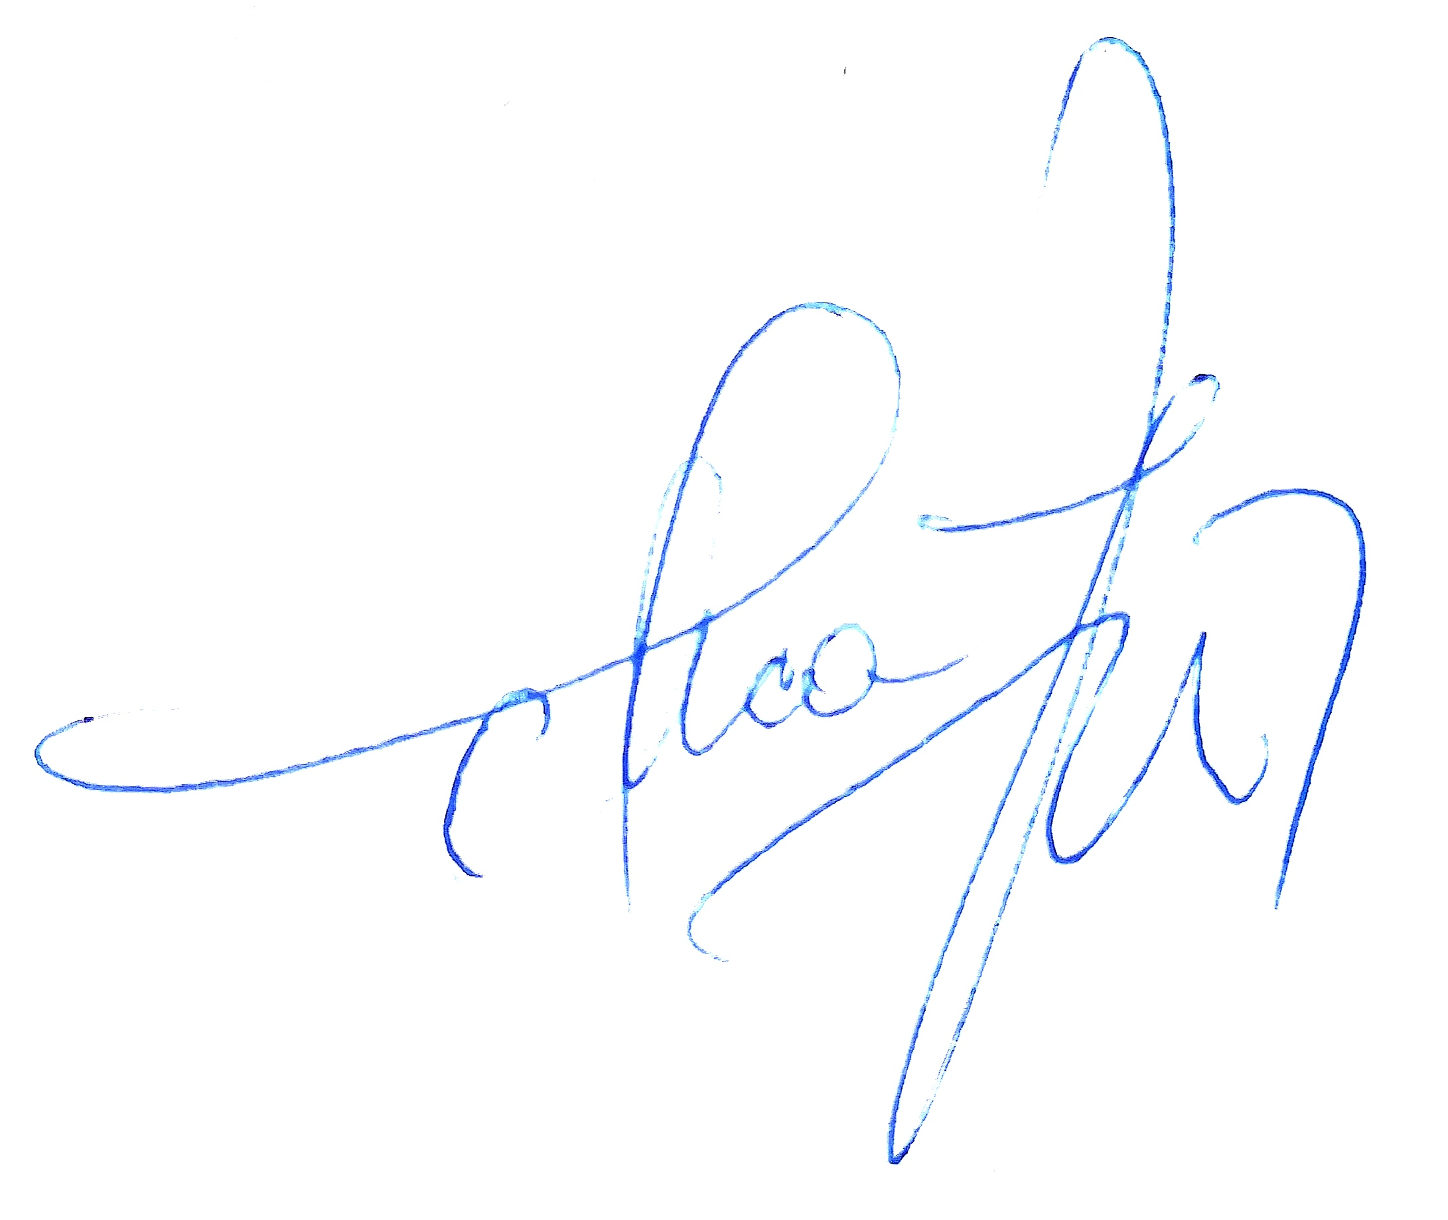
Data avizării în departament |  | Semnătura directului de departament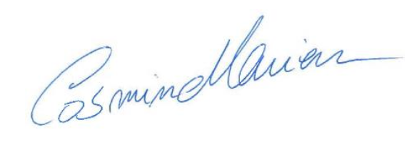
25.09. 2024

